**Module 1 Challenge**

Crowdfunding

Kavish Naran

**UWA DATA ANALTICS BOOTCAMP**

1. Given the provided data, what are three conclusions that we can draw about crowdfunding campaigns?

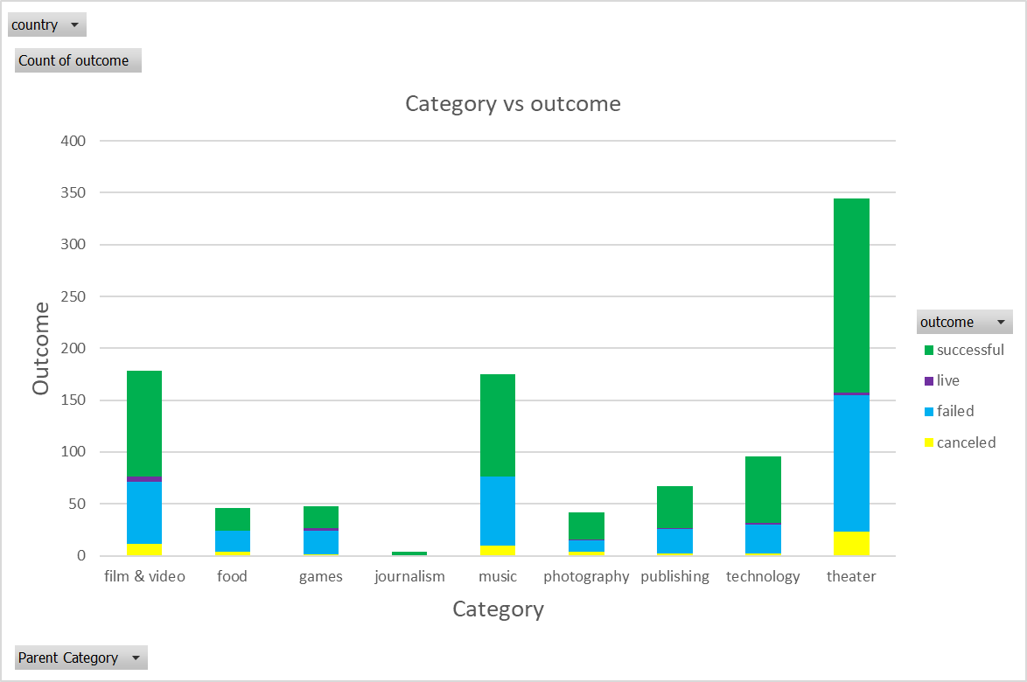Looking at the provided crowdfunding campaigns dataset, the top three parent categories were theater (344), film and video (178) and music (175). Film & Video has the highest success rate (57.3%), followed by Music (56.6%) and Theatre (54.4%). Journalism, food and photography were the least popular parent categories. This data can be visualised on Figure 1

Figure : Category vs Outcome

Taking a deeper look into the sub-categories plays (theatre) were the most popular, followed by rock (music) and documentary (film and video). This aligns with the outcomes on the parent categories. The data from the sub-categories can be visualised in figure 2.

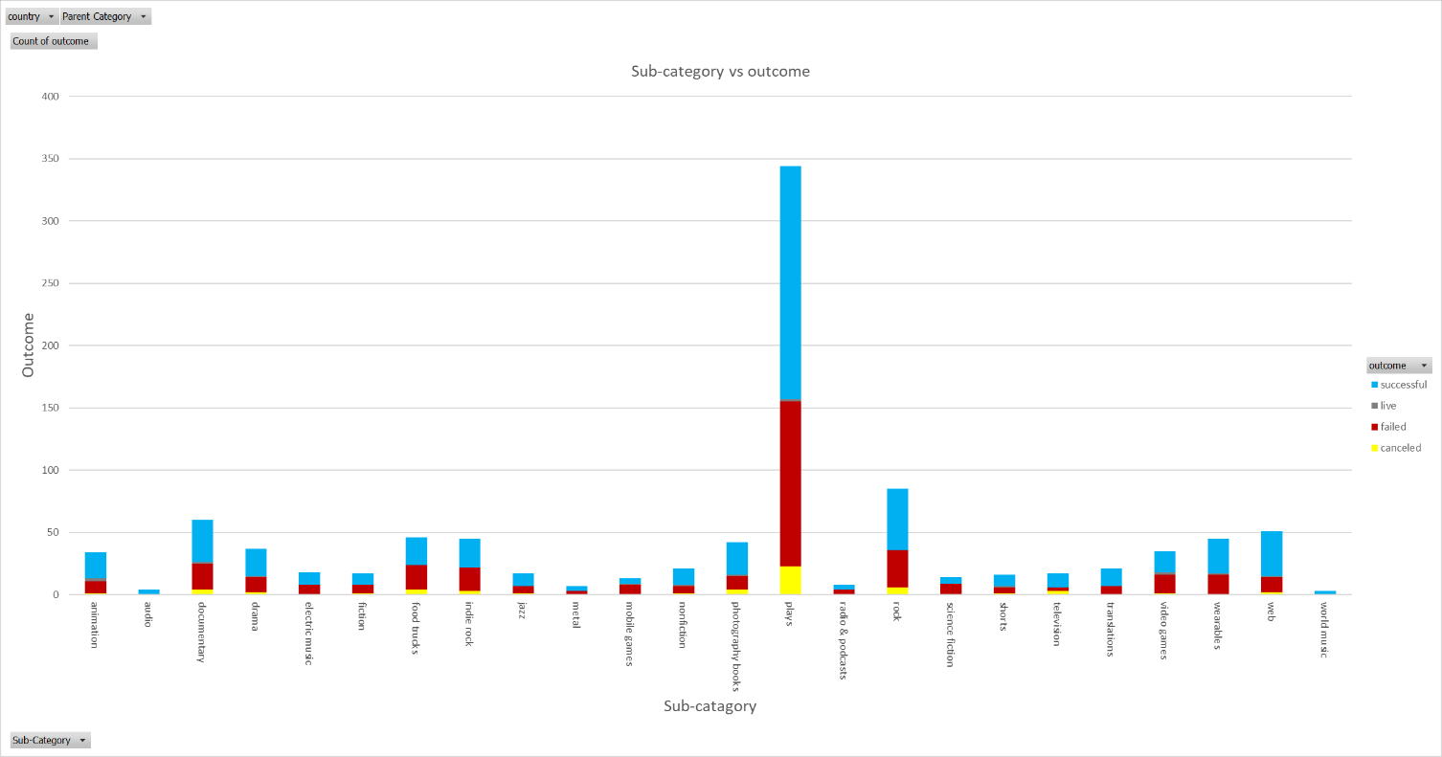

Figure : Sub-category vs outcome

The data in figure 3 indicates there was a reduction in crowdfunding projects between February and April, there was an increase from May to July and another decline from July to September.

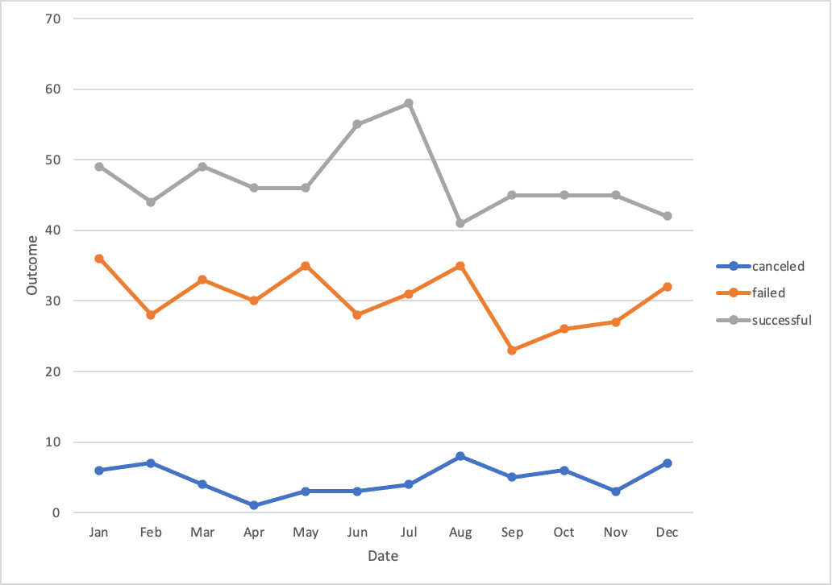

Figure : Outcome vs Date

Summary

* On average more crowdfunding projects were successful rather than failed or cancelled

1. What are some limitations of this dataset?

* The data set only contains data for seven countries (Australia, Canada, United States, China, Italy and Denmark). Therefore, does not contain data from other countries. The seven countries are all first world countries which could lead to the data set being biased.
* Limited number of categories and subcategories with only a 1000 data points, a larger data set would provide more information and diversify the data set.
* For those crowdfunding projects which failed, no reasoning was provided to why they failed.

1. What are some other possible tables and/or graphs that we could create, and what additional value would they provide?

* Pie chart to display successful, failed and cancelled crowdfunding projects.
* Bar graph to display goal vs pledged amount raised.
* Table to show how long each crowdfunding project was active for.